13th Annual Ancient Order of Hibernians Polar Plunge

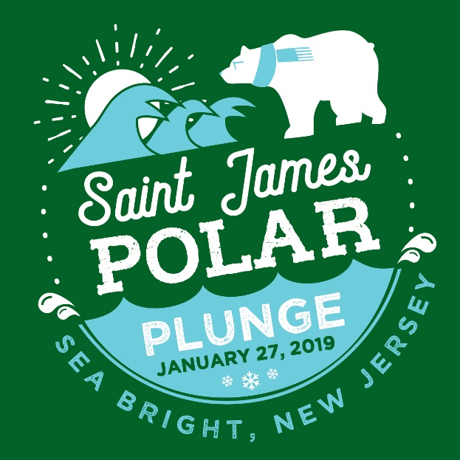

Sunday, January 27, 2019
Sea Bright Municipal Beach
1099 Ocean Avenue, Sea Bright

- 12:30 pm Meet by the SJS flags at the beach
- 1:00 pm Plunge in the ocean
- 1:15 pm After party at Tommy’s Tavern

For more information and sponsor forms, please visit our website: mysaintjames.com

